VibeCheck

<https://github.com/comp195/Spring2020Project-vibecheck>

Devin French (d_french3@u.pacific.edu)

Seth Kith (s_kith@u.pacific.edu )

# Table of Contents

**Background** 3

**System Architecture:**4

**Hardware, Software, and System Requirements:**5

**External Interfaces**6

**Software Design**7

Class Diagram: 7

Interaction Design: 8

UML Interaction Diagram 9

**User Design Interface**10

**Glossary of Terms**11

**References**12

# **Background:**

VibeCheck is a new web social media platform. Users will be able to sign up free or use their current facebook accounts to sign-in. It will provide users a new way to connect with others like friends, co-workers, or sometimes meeting new people online. Users will be able to share posts/thoughts, statuses, locations, music, videos, and many more.

**Features:**

* Share
  + Music
  + Status - Opinions, Thoughts, etc.
  + Images
* Custom Profiles - Similar to Myspace profiles
  + Music player
  + Images
  + Themes (Color themes)
  + Edit information
* View
  + Home Feed (Posts from other users)
  + Profiles
  + Friends

# 

# System Architecture:

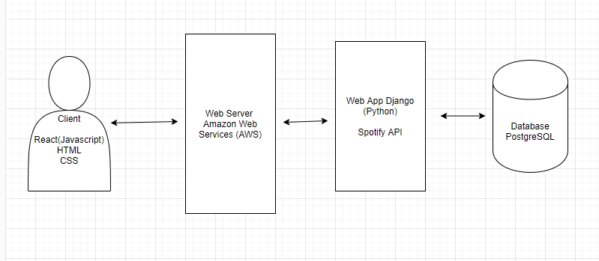

The client’s computer will submit HTTP2 requests to the web server (Amazon Web Services) which will reach end points controlled by the Django web framework. Depending on what end point is requested, the PostgreSQL database will be queried for data or various third party APIs will be queried. The React front end framework will then render the data retrieved from the web server and output it to the user.

# 

# Hardware, Software, and System Requirements:

**Hardware Requirements:** Accessible with any device both mobile and computer that has an internet browser. These devices should be able to connect to the internet using either WiFi, Ethernet connections, or cellular networks.

**Software Requirements:**

* Django (Python)
* Django REST framework4
* Amazon Web Services (AWS lightsail)
* PostgreSQL
* Namecheap
* React
* Redux
* Webpack
* Babel
* SASS

**System Requirements:** Accessible with any OS that has an internet browser installed.

# 

# External Interfaces

Not applicable.

# Software Design

## Class Diagram:

## 

## Interaction Design:

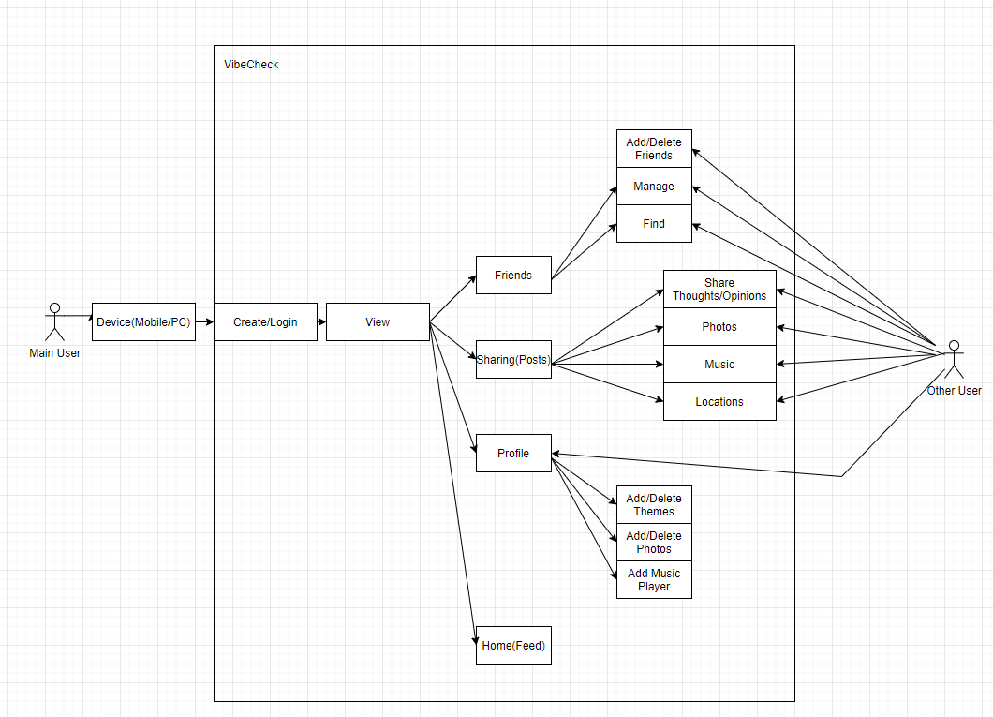

UML Interaction Diagram: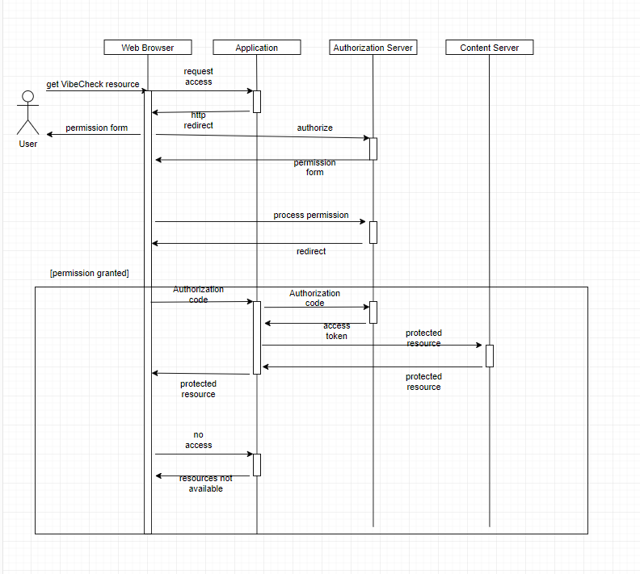

# User Design Interface

Getting started: Users will first access the website through a web browser. Depending if the user has an account, the user will be required to login to gain access. Users will be greeted with a welcome screen and a prompt to either login or sign up. It will ask for a name, birthdate, password, and an email address.

Home: After logging in/signing up, users will be greeted to the home screen. This is where users will see posts, find friends, and interact with others. There will be an option to customize your home feed such as changing it to either dark or light1 mode.

Posts: A text box will appear in the home feed. Users can share: music, opinions/thoughts, or etc. There will be a character limit of 250 characters, but if the user wants to post something that exceeds the character limit, they’ll be given an option to share it as a story. These stories will have a short preview and if other users wish to read to it, they can expand and read it.

Profiles: Users have the option to customize their profiles. They can display who their friends are, a music player, and change the theme of their profile with either simple color themes, or upload pictures for their theme. For advanced users, they can create their own customized profiles.

# 

# Glossary of Terms

Dark or Light1 - Most common background themes. Users seem to like either dark or light themes.

HTTP2 - HyperText Transfer Protocol, the foundation of data communication for the World Wide Web.

API3 - Application Programming Interface is an interface or communication protocol between different parts of the program. It allows easier implementation and maintenance within the software.

Framework4 - Similar to APIs, it provides a foundation for developers to build programs for specific platforms using predefined classes and functions.

# References

Christensson, P. (2013, March 7). *Framework Definition*. Retrieved 2020, May 1, from https://techterms.com

Beal, V. (n.d.). HTTP - HyperText Transfer Protocol. Retrieved from https://www.webopedia.com/TERM/H/HTTP.html

Gazarov, P. (2019, December 19). What is an API? In English, please. Retrieved from https://www.freecodecamp.org/news/what-is-an-api-in-english-please-b880a3214a82/